CI Jenkins

Even though documenting the assignment wasn’t needed:

1. Start Jenkins inside a Docker container
2. Connect to <http://VMIP:JENKINSPORT/>
3. Use token to log in
4. Install the recommended plugins
5. Set up an account/password for Jenkins
6. Create a new item inside Jenkins as a Freestyle project

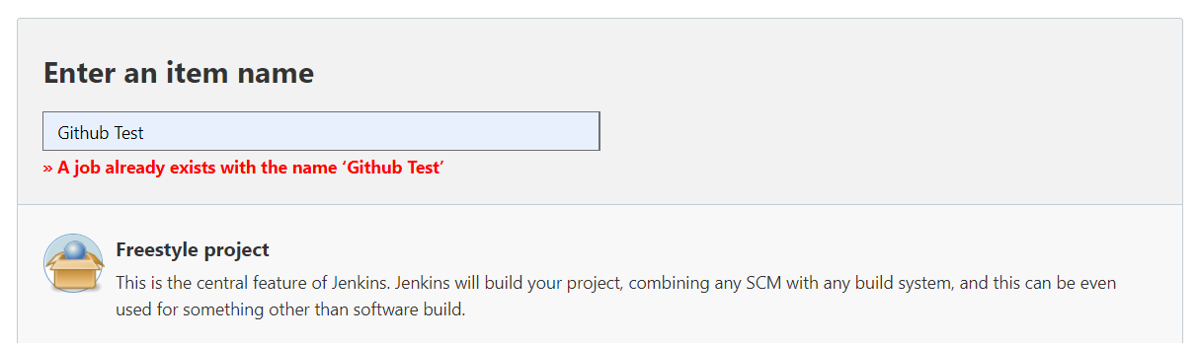

1. Set settings as a Github project

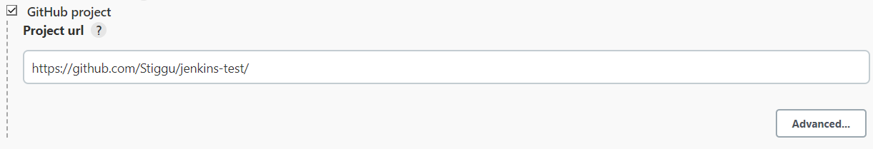

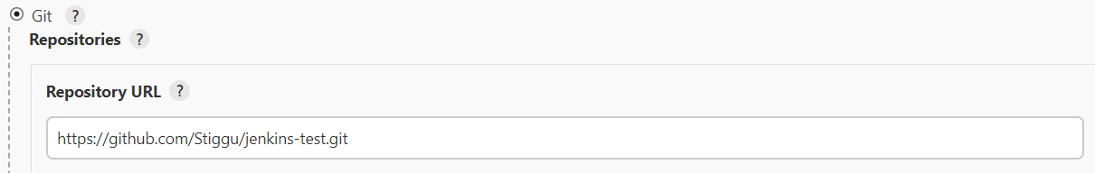

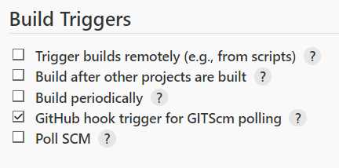

1. Set up NGROK so Github is able to connect to the VM
2. In Github project settings add a new Github for Jenkins using the NGROK address

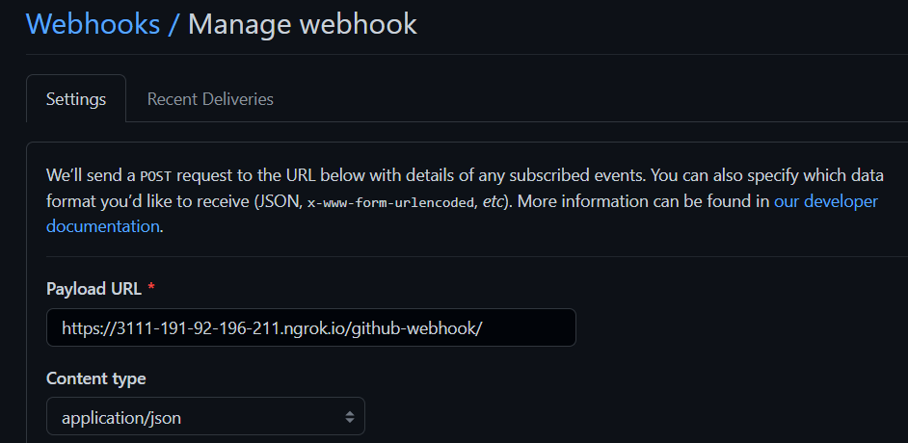

1. Push something and check if Jenkins build was successful

